Michael Lee

Russell Whaley

COMP3700

Group Project

10/20/17

Use Cases

**Add Product:**

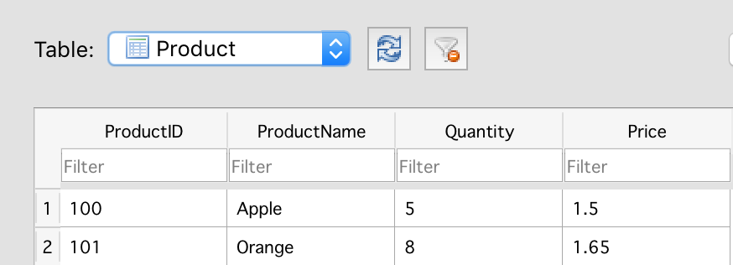

*Initial Database before adding products

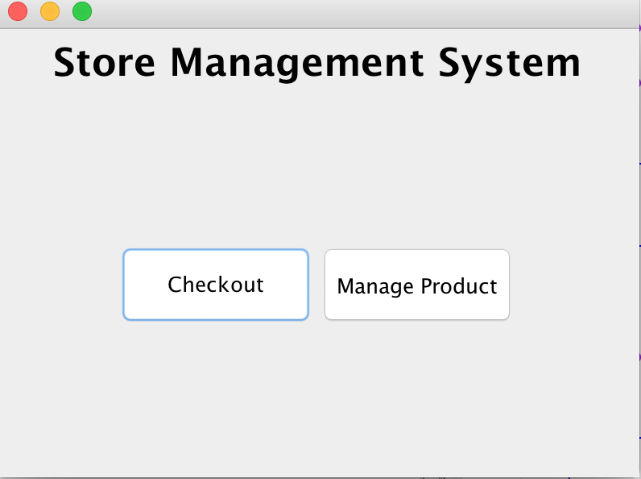

*Select Manage Product Button

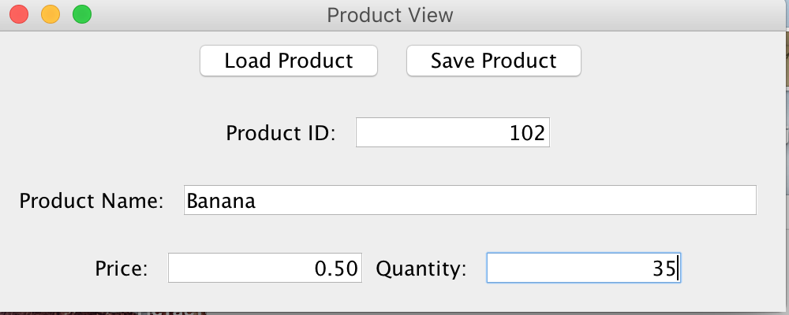

*Enter New Product Information and click Save Product Button

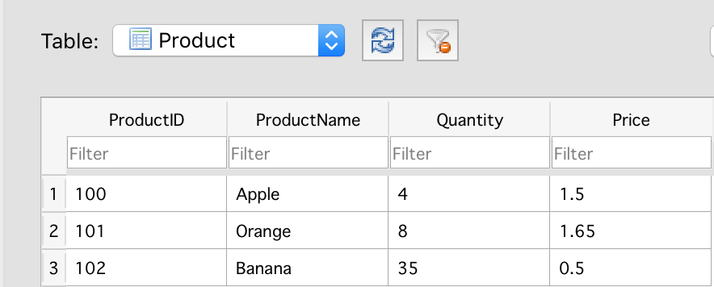

*Updated Database after new product was added (bananas)

**Update Product:**



*Click Manage Product

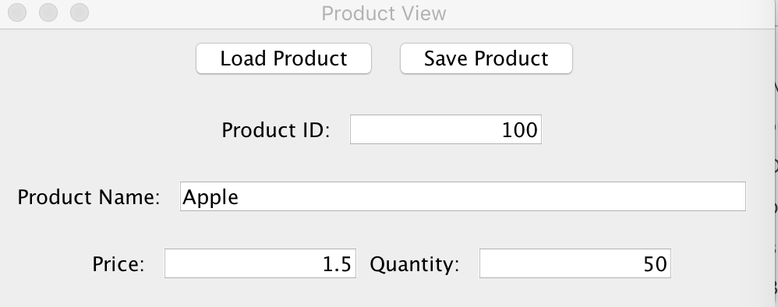

*Update Product Info and select Save Product

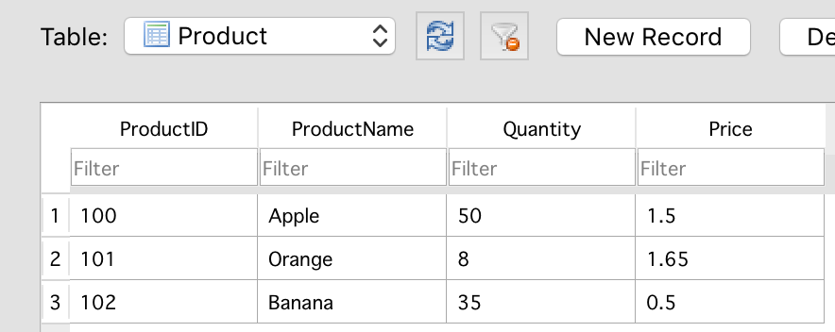

*Updated Database after Apple product quantity was updated

**Checkout:**



*Click Checkout Button

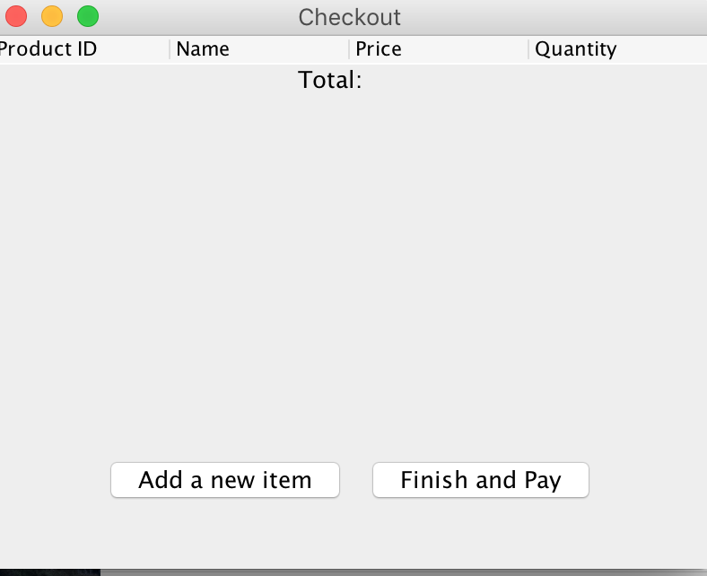

*Click Add a new item Button (repeat for all products of order, select finish and pay when finished added all products of order.)

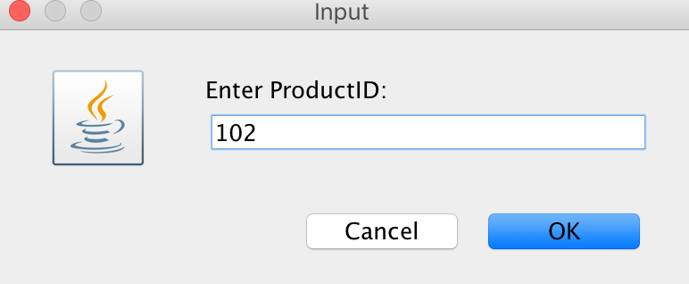

*Enter ProductID and click OK button(repeat for all products of order)

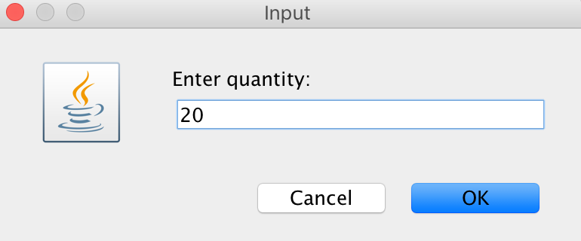

*Enter quantity and press OK(repeat for all products of order)

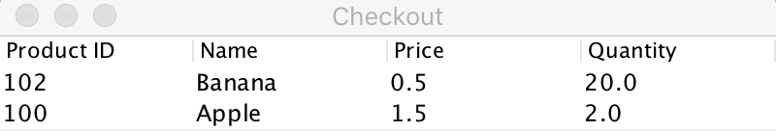

*Updated Checkout screen.

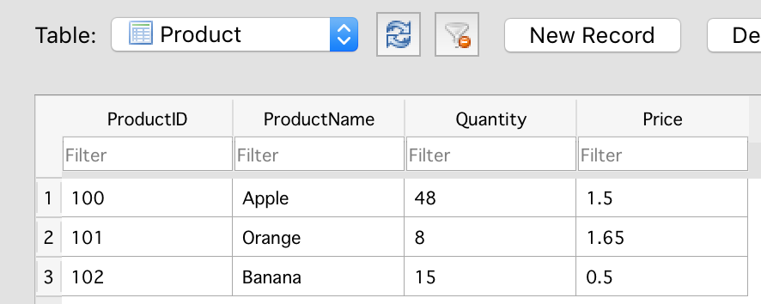

*Updated database after Checkout is complete.